

London, United Kingdom

*Prepared by Ari Hespersson, Technology Systems Lead*

System Architecture

At the London, UK regional office for A++ Logistics we employ a three-prong system for managing our logistics data.

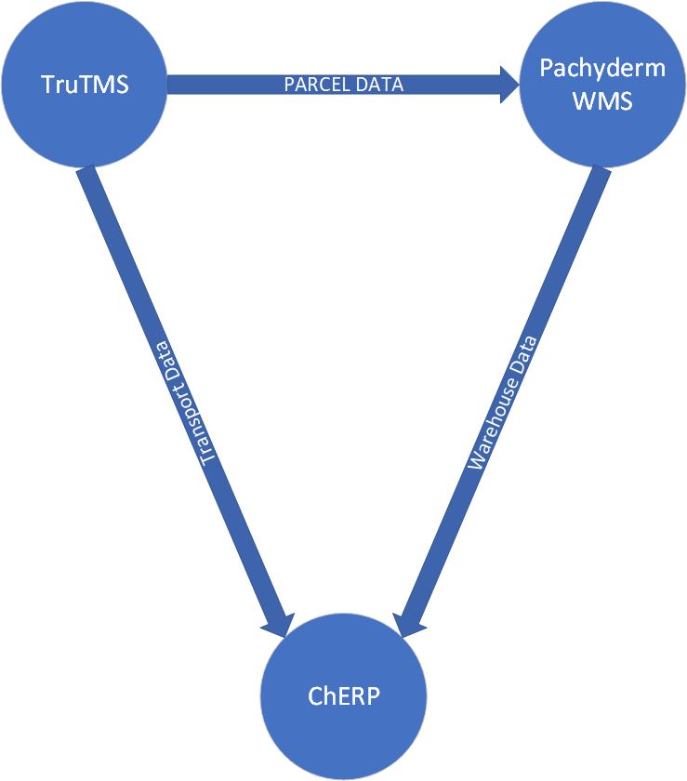

***Figure 01****: London system architecture*

As you can see in figure 01 above, our architecture consists of the ChERP core, TruTMS transportation management, and Pachyderm warehouse management. TruTMS communicates with Pachyderm via direct plugin to transmit all parcel data related to warehouse management, and it communicates with ChERP through the ChERP client, which permits the uploading of raw XML data as collected by the TruTMS system.

TruTMS annual cost: £ 4490.0

Pachyderm annual cost: £ 9550.0

I trust this is what you require to get the job done.

Cheers.